**Bug 1 Output:**  
  
A service item of type bar fridge is selected at a cost of $5  
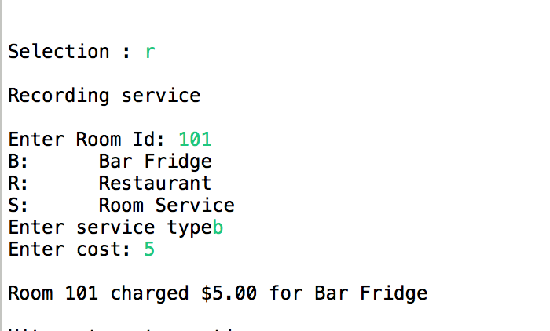

After selecting check out and entering the room number incorrect charges of $0 are then displayed for the service item

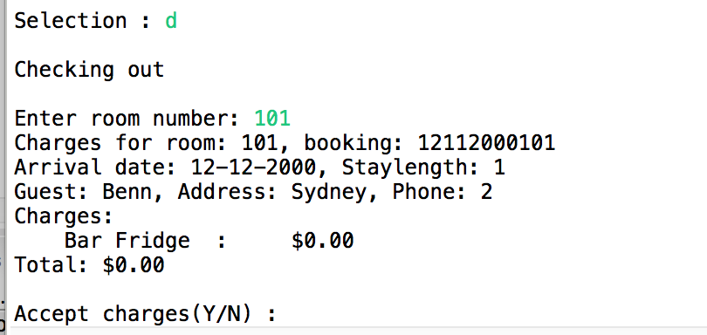

**Output after bug 1 fixed:**A service item of type bar fridge is selected at a cost of $5

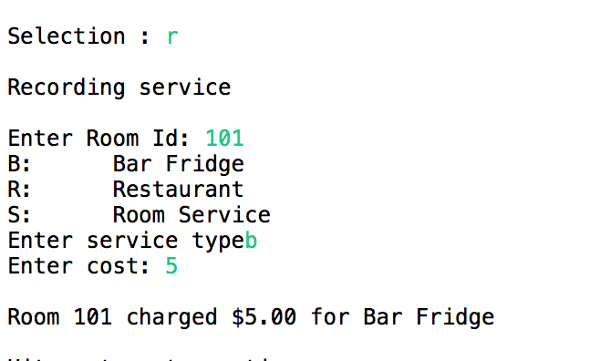

After selecting check out and entering the room number correct charges of $5 are then displayed for the service item  
